xpedx.com Next generation
Order Change And Cancel In WebChannel Design Document

Authors: Sterling Commerce

Date Created: 04/26/10
Last Updated: 06/30/10
File Name: C:\Documents and Settings\bfurman\My Documents\Temp\Methodology v1.1\Project Management\TEMPLATE - DOCUMENT - Use Case Definition.docxpedx Change Order And Cancel In WebChannel Detailed Design V1.7.doc

Approval Signatures (Mandatory)

Title | Name | Signature | Date | Comments / Issues / Concerns
xpedx Owner(s) | Steve Bugher
xpedx Owner(s) | Cheryl Tullis
Sterling Commerce Owner(s) | Guy Read

Note: The sign off indicates approval of all sections of the document.

Document Revision History

This chart tracks the changes introduced by the revisions to the document as the project progresses through the stages of the System Development Life Cycle (SDLC).

Version | Date | Description (Changes Made) | Author(s)
1.0 | 04/26/2010 | Initial Draft | Sterling
1.1 | 04/28/2010 | Ready to deliver | Sterling
1.2 | 05/28/2010 | Incorporated feedbacks | Sterling
1.3 | 06/02/2010 | Incorporated changes from 6/1/10 meeting with Steve, George and Chris, Cheryl and Jasmine | Sterling
1.4 | 06/07/2010 | Incorporated changes proposed to the values in the matrix table | Sterling
1.5 | 06/25/2010 | Minor feedback changes incorporated | Sterling
1.6 | 06/30/2010 | Ship Complete Changes | Sterling
1.7 | 06/30/2010 | Correct Definition of Order Cancel, minor updates to table. | Sterling

Related or Reference Documents

Document Name | Description | Owner | Location
SCI_Xpedx Solution Definition Document v1.5 | Solution Definition document | Sterling Commerce
SCI_xpedx_Order Status_v2.0 | Status Mapping document | Sterling / xpedx

TABLE OF CONTENTS

1. Introduction 5
1.1 Document Purpose 5
1.2 Document Audience 5
2 Order Change and Cancel in Web Channel 6
2.1 Functions & Solution 6
2.1.1 Order Change 7
2.1.2 Order Cancel 14
2.2 Master System 14
2.3 Implementation Details 14
2.3.1 Entity objects. 14
2.3.2 Actions involved and Functions 15
2.3.3 API Details 15
2.4 Process Flow 15
2.5 Screen Shot 16
2.6 Open Questions 17
2.7 Assumptions 17
3 Glossary of Terms 18

Introduction

Document Purpose

This document is the governing functional design document for Order Change and Cancel in Web Channel functionality. It presents significant decisions and constructs used in developing the functionality. Testing, builds, configuration management are not covered in this document.

The document will also serve the purpose of keeping a list of assumptions that were made during design discussions.

Document Audience

This document is intended for management and technical staff working on this project, xpedx IT and Business, webMethods, Legacy(MAX and ACCESS), HP, IW, xpedx/IP Network Team. Sterling will use the document during design and configuration for design consideration.

Order Change and Cancel in Web Channel

Functions & Solution

Order Change and Cancel are post Order placement process to provide the user the ability o change or cancel the order. This is in addition to the CSR capability of changing and cancelling the order. These actions are provided to the user in the order detail page. The options show up based on order status and order modification rules. Sterling change / cancel order rules will be tweaked based on xpedx requirements. The extent of changing the rules will be to grant / deny changes at a transaction level. For e.g, if Coupon change needs to be allowed on an order we will enable the order modification rule to grant the coupon change transaction on the order. This can be done through the Application Manager application by an xpedx administrator. Please see the screen shot for the example.

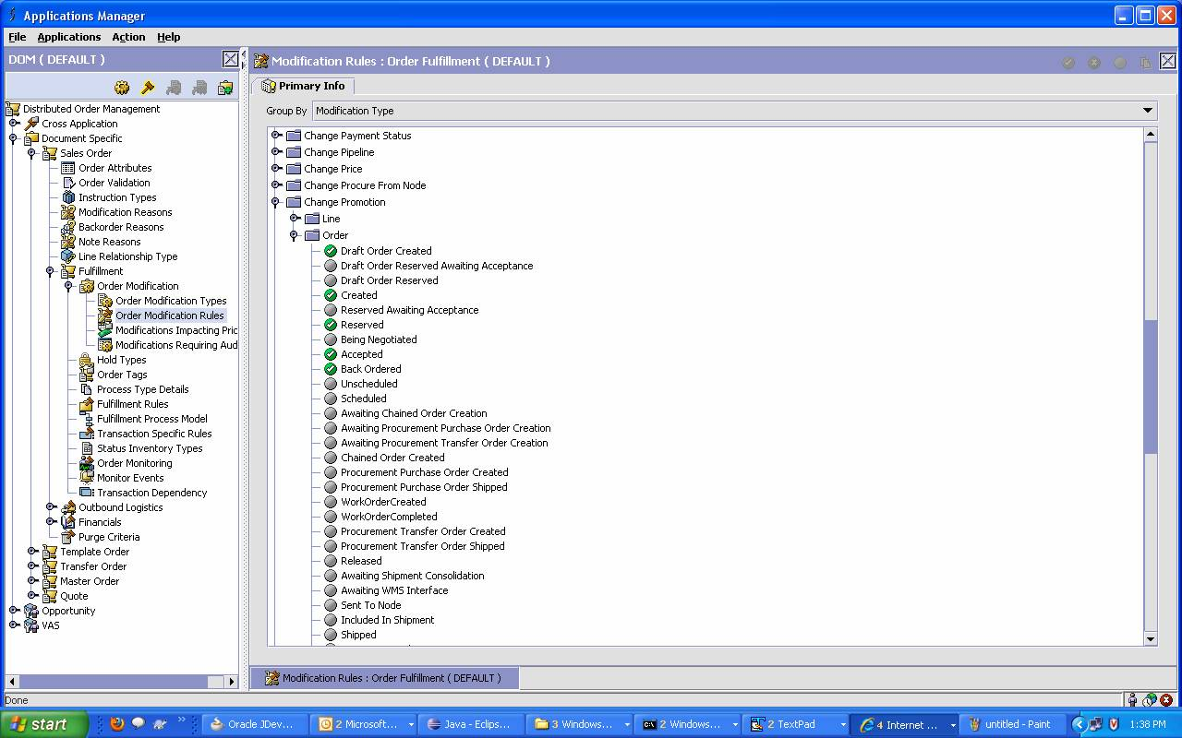

Order Change

The change order functionality enables a user to change an order and details of an order, based on the modification rules configured in the system. The change order functionality enables a user to perform the following functions:

The table below indicates which fields can be read or updated as part of order placement or order change in Web Channel and Call Center. A new order is defined as an order that has not yet been submitted to legacy.

 | Web Channel |  |  |  | Call Center
Field | New Order |  | Edit Order |  | New Order |  | Edit Order
 | Customer Order |  | Fulfillment Order |  | Customer Order |  | Fulfillment Order
 | User | System | User | System | User | System | User | System | Comments
Source Indicator | NA | Update | NA | Read | NA | Update | NA | Read
Transaction Code | NA | Read | NA | Read | NA | Read | NA | Read
Transaction Error  Message | NA | Read | NA | Read | NA | Read | NA | Read
Environment ID | NA | Update | NA | Read | NA | Update | NA | Read | System populates from customer profile
Company Code | NA | Update | NA | Read | NA | Update | NA | Read | System populates from customer profile
Web Confirmation | NA | Update | Read | Read | NA | Update | Read | Read
Ordering Division | NA | Update | Read | Read | NA | Update | Read | Read
Legacy Order Number | NA | Read | Read | Read | NA | Read | Read | Read
Generation Number | NA | Read | Read | Read | NA | Read | Read | Read
Legacy Order Type | NA | Update | Read | Update | NA | Update | Read | Update
Web Hold Flag | NA | Update | Read | Update | NA | Update | Read | Update
Web Hold Reason | NA | Update | Read | Update | NA | Update | Read | Update
Ship From Division | NA | Update | Read | Read | NA | Update | Update | NA
Customer Division | NA | Update | Read | Read | NA | Update | Read | Read
Customer Number | NA | Update | Read | Read | NA | Update | Read | Read
Ship to Suffix | Read | Update | Read | Update (you mentioned Read, but what if the shipping address is overridden in that case, doesn’t the system needs to set the value to 999) | Read | Update | Read | Read
Ship to Name | Read | Update | Read | Read | Read | Update | Read | Read
Attention Name | Update | Read (the system is not updating it, so why should it be update) | Update | Read | Update | Update | Update | Read
Ship to address1 | Update | Update | Read | Read | Update | Update | Read | Read | All Ship to updates based on customer profile.
Ship to address2 | Update | Update | Read | Read | Update | Update | Read | Read | All Ship to updates based on customer profile.
Ship to address3 | Update | Update | Read | Read | Update | Update | Read | Read | All Ship to updates based on customer profile.
Ship to City | Update | Update | Read | Read | Update | Update | Read | Read | All Ship to updates based on customer profile.
Ship to State | Update | Update | Read | Read | Update | Update | Read | Read | All Ship to updates based on customer profile.
Ship to ZIP | Update | Update | Read | Read | Update | Update | Read | Read | All Ship to updates based on customer profile.
Ship to Country | Update | Update | Read | Read | Update | Update | Read | Read | All Ship to updates based on customer profile.
Bill to Suffix | Read | Update | Read | Read | Read | Update | Read | Read | System populates from customer profile for the selected ship-to
Bill to Address1 | Read | Update | Read | Read | Read | Update | Read | Read | System populates from customer profile for the selected ship-to
Bill to Address2 | Read | Update | Read | Read | Read | Update | Read | Read | System populates from customer profile for the selected ship-to
Bill to Address3 | Read | Update | Read | Read | Read | Update | Read | Read | System populates from customer profile for the selected ship-to
Bill to City | Read | Update | Read | Read | Read | Update | Read | Read | System populates from customer profile for the selected ship-to
Bill to State | Read | Update | Read | Read | Read | Update | Read | Read | System populates from customer profile for the selected ship-to
Bill to ZIP | Read | Update | Read | Read | Read | Update | Read | Read | System populates from customer profile for the selected ship-to
Bill to Country Code | Read | Update | Read | Read | Read | Update | Read | Read | System populates from customer profile for the selected ship-to
Customer Header PO Number | Update | Read | Update | Read | Update | Read | Update | Read
Order Code | Update | Read | Update | Read | Update | Read | Update | Read
Ship Complete | N - Fill & Kill: UI – Don’t show checkbox. message on the Cart 'Only available quantity will be shipped' in Partial Availabilty scenario  C - Ship Complete: UI – Show checkbox grayed out but checked.  Y - Allow Backorders: UI – Show checkbox. Default is unchecked.  If xcom Ship Complete flag is checked, on Order Placement send 'C' to legacy (Web Methods will change to N for MAX, C for ACCESS), meaning customer wants entire order to be delivered in one shipment and will wait for product to arrive | Read | NA | Read | Update (Drop down with 3 values, CSR can change the default value on the order populated from the customer profile) | Read | Update (Drop down with 3 values, CSR can change the default value on the order populated from the customer profile) | Read | System populates from customer profile. This determines if the order can be backordered of fill&kill.
Will Call | Update | Read | Read | Read | Update | Read | Update | Read
Ship Date | Update | Read | Read | Read | Update | Read | Update | Read
Header Comments | Update | Read | Read | Read | Update | Read | Update | Read
Ordered By Name | NA | Update | Read | Read | NA | Update | Read | Read
Order Create Date | NA | Update | Read | Read | NA | Update | Read | Read
Order Source | NA | Update | NA | Read | NA | Update | Read | Read
Header Process Code | NA | Update | NA | Update | NA | Update | NA | Update
Order Status | NA | Update | Read | Update | NA | Update | Read | Update
Order Status Comment | NA | Update | Read | Update | NA | Update | Read | Update
Currency Code | Read | Update | Read | Read | Read | Update | Read | Read
Total Shippable Value | Read | Update | Read | Update | Read | Update | Read | Update
Total Order Value | Read | Update | Read | Update | Read | Update | Read | Update
Order Special Charges | Read | Update | Read | Update | Update | Update | Update | Update
Total Order Freight | NA | NA | Read | Read | NA | NA | Read | Read
Total Order Tax | NA | NA | Read | Read | NA | NA | Read | Read
Header Status Code | NA | Read | NA | Read | NA | Read | Read | Read
Web Line Number | NA | Update | NA | Update | NA | Update | NA | Update
Legacy Line Number | NA | Read | NA | Read | NA | Read | NA | Read
Line Process Code | NA | Update | NA | Update | NA | Update | NA | Update
Line Type | NA | Update | NA | Update | NA | Update | NA | Update
Legacy Product Code | Update | Update | Read | Read | Update | Update | Read | Read
Customer Product Code | Update | Update | Read | Read | Update | Update | Read | Read | “New line can be added. Existing line will be managed using xpedx part#.”
Base Unit of Measure | NA | Update | NA | Read | NA | Update | Read | Read
Ordered Qty in Base UOM | NA | Update | NA | Update | Update | Update | Update | Read
Price Unit of Measure | Read | Update | Read | Read | Read | Update | Read | Read
Unit Price in pricing UOM | Read | Update | Read | Update | Update | Update | Update | Update
Line Description | Update | Update | Read | Read | Update | Update | Update | Read | For special items the user can update the line desc
Price Override Flag | NA | Update | NA | Read | NA | Update | NA | Read
Requested Unit of Measure | Update | Read | Read | Read | Update | Read | Update | Read
Ordered quantity in requested UOM | Update | Read | Update | Read | Update | Read | Update | Read
Shippable Qty in Requested UOM | NA | Read | Read | Read | NA | Read | Read | Read
Shippable Qty in Base UOM | NA | Read | NA | Read | NA | Read | Read | Read
BackOrder Qty in Requested UOM | NA | Read | Read | Read | NA | Read | Read | Read
BackOrder Qty in Base UOM | NA | Read | NA | Read | NA | Read | Read | Read
Customer line sequence number | NA | Read | Read | Read | NA | Update | Update | Read
Customer Line PO # | Update | Read | Update | Read | Update | Update | Update | Read | System will update customer fields for B2B orders.
Customer Line Account Number | Update | Read | Update | Read | Update | Update | Update | Read
Customer field 1 | Update | Read | Update | Read | Update | Update | Update | Read
Customer field 2 | Update | Read | Update | Read | Update | Update | Update | Read
Customer field 3 | Update | Read | Update | Read | Update | Update | Update | Read
Ship from Branch | NA | Update | NA | Read | NA | Update | Update | Read | Need to revisit for CTC change request
Line Notes | Update | Read | Read | Read | Update | Read | Update | Read
Adjustment dollar amount | NA | Update | Read | Read | NA | Update | Read | Read (you mentioned Update HOW?)
Coupon Code | Update | Read | Read | Read | Update | Read | Read (you mentioned Update HOW?) | Read
Shippable Qty Line Total | NA | NA | Read | Read | NA | NA | Read | Read
Ordered Qty Line Total (Extended) | NA | Update | Read | Update | NA | Update | Read | Update
Line Status Code | NA | Read | NA | Read | NA | Read | Read | Read

The order detail page will have the ‘Change’ action. The button will show up depending on the order status. The following status will allow Change Order for an end user:

- Created
- Placed
- Hold (Pending Approval)
- Open
- Hold (Customer Hold
- Hold (Web Hold)
- Hold (System)

The Order modification rules are specified at two levels.

- Order Header Level: The modification rules specified for the order header level affect modification of order header level information. Some of the order header level changes include changes Header Comments, Attention Name etc.
- Order Line Level: The order line change is similar to the order header change. The order lines changes include removing an order line, changing the line item quantity etc.

The changes are committed only when the user has clicked on submit and the changes are sent over to Legacy.

Order Cancel

When the user clicks on the Cancel Order button, a re-confirmation box will show up where the user has to confirm his action. Once the action is confirmed, the cancellation request will be sent out to Legacy. The request will contain the order object. We will read the transaction status and if it is says SUCCESS; we will cancel the order in the Sterling database. If the transaction status is an ERROR, we will show the user friendly message to the user that the cancellation of the order failed.

A user can cancel an “open order” with coupons at any time. Orders with the list of order statuses below with coupons may be canceled, but once the order has hit the warehouse (released) it may no longer be canceled. Refer to the Order Place DDD for specific order statuses.

The order detail page will have the ‘Change’ action. The button will show up depending on the order status. The following status will allow Change Order for an end user:

- Created
- Placed
- Hold (Pending Approval)
- Open
- Hold (Customer Hold)
- Hold (Web Hold)
- Hold (System)

Master System
Legacy is the master of system for Order Changes and Cancellation.

Implementation Details
Order Place interface will be used for sending the change order transactions to Legacy. The header process code will have ‘C’ in that case and will carry both the web confirmation number and the Legacy order number.

Entity objects.
- NA

Actions involved and Functions
Following new Actions are introduced to achieve the required functionality on top of OOTB
- XPEDXChangeOrderAction.java
- XPEDXCancelOrderAction.java

API Details
Following APIs will be called to achieve the functionality.

- getCompleteOrderDetails– This API will return the order details along with the modification rules that the user is entitled to for the order.
- changeOrder - This API will be called to change an existing order.

Process Flow

Not Applicable

Screen Shot

The screen shots pasted here are still in review and not final. This is just an illustration of how it should look like.

Order Detail Page (with Update / Cancel Order)

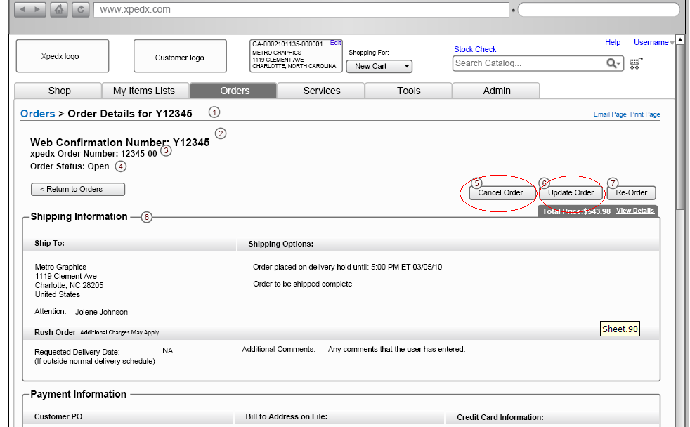

Open Questions
- If the header Customer PO changes then if any line PO changes will be made in .com and sent as desired to MAX. MAX should not change the line po # in response to the line. – This was mentioned in the change able field list in MAX / Access we got from George. Please clarify.
- Are we saying the ship address fields cannot be overwritten after an order is placed (according to changeable field document send out by George). Answer: The ship to physical address can be changed based on ship to override field in the customer profile. But the account / ship to cannot be changed.
- All the price related fields (like Total Order Value, Extended Line total) can change in order change (It says NO in the changeable field document send out by George). Answer: That’s fine; Sterling will anyway send the extended total values, if Legacy wants to re-calculate that’s fine. But it has to be consistent with what Sterling has calculated; otherwise, the user will see some value on the web during order change or placement and might be some other value later.
- Price Override Flag – Why does it say blank to ‘P’. Not ‘P’ to blank. (What does this mean).
Answer: Confirmed with George, this could happen if the Legacy has changed to blank during order update and then the customer is changing the order. In that case sterling will send blank even though it has sent a ‘P’ during order placement. Please check with Legacy if this is an issue.
- Coupon & Adjustments need to be re-visited when promotions are finalized.

Assumptions
- Order Change flow is similar to the check out flow for a new order.
- Cancel Order cancels the whole order from web channel. If line level cancels needs to be done, that would be a change Order scenario where the user can change the order and delete the line.
- If there is a lag between the users submits the order changes and status change in Legacy for that order, the order changes might not be accepted by Legacy and an error will be sent back to Sterling in that case.
- If the non-stock line in the order is attached to a supplier PO then it is the responsibility of Legacy that they mark the order as backordered or some other status in which case it should not be allowed for Change or Cancel.
- All the derived orders (such as -01) will have back ordered status set by Legacy and sent to Sterling so that those orders are not editable or cancelled in Sterling. Only the parent fulfillment order (such as -00) can have a status where it can be modified or cancelled.
- User should be able to edit and cancel the orders if the order is in a state in which it can be cancelled no matter the order has a coupon or pricing discount applied to the order.
- Pricing rule or coupon will not be calculated during order change. The order modification rules need to be adjusted accordingly.

Glossary of Terms

S. No. | Term | Definition
1. | Entity Object | Database and Java entity objects to store the required data.
2. | Action Class | Struts controllers which redirects the parameters and does some business logic before calling the business APIs.
3. | BR1 | Business Release 1
4. | IW | Industrial Wisdom – UI firm engaged on the project.
5. | OOTB | Out of the box

